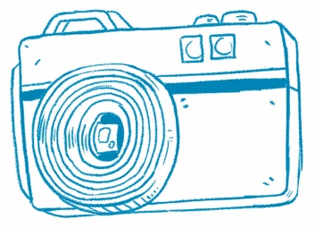**Picture This**

**Understanding Photos.** Photos can help you understand what an article is about.

Article Title

Draw or write about one photo from the article.

Why is the photo important? Use words from the article.