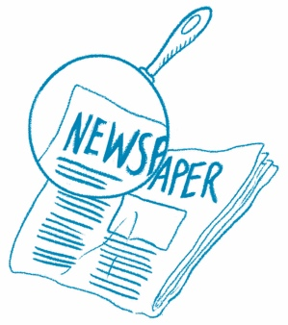
The Big Picture
Main Idea What is this article mostly about?
Draw or write the main idea. Then draw two details that support the main idea.
Article Title

Main Idea

Detail
Detail

