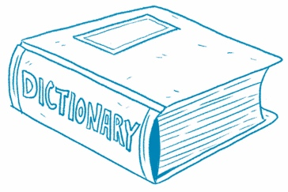**What’s That Word?**

**Build Vocabulary** Clues from the text help you   
understand new words.

Article Title

Find a bold word in the article. Write the word.

Use the word in a sentence or draw a picture.

What does the word mean? Write the definition.